_________________________________________________________________________________
Software Requirements
Specification
for
Public Grievance Redressal System
(PGRS)
Version 1.0 approved
Prepared by Adhikesavan
Department of Computer Science and Engineering
October 2026
Copyright © 2026 by PGRS Team. Permission is granted to use, modify, and distribute this document.

Table of Contents
Table of Contents............................................................... ii
Revision History................................................................ ii
1. Introduction................................................................. 1
1.1 Purpose.................................................................. 1
1.2 Document Conventions..................................................... 1
1.3 Intended Audience and Reading Suggestions................................ 1
1.4 Product Scope............................................................ 1
1.5 References............................................................... 2
2. Overall Description.......................................................... 2
2.1 Product Perspective...................................................... 2
2.2 Product Functions........................................................ 2
2.3 User Classes and Characteristics......................................... 3
2.4 Operating Environment.................................................... 5
2.5 Design and Implementation Constraints.................................... 5
2.6 User Documentation....................................................... 5
2.7 Assumptions and Dependencies............................................. 6
3. External Interface Requirements.............................................. 6
3.1 User Interfaces.......................................................... 6
3.2 Hardware Interfaces...................................................... 6
3.3 Software Interfaces...................................................... 7
3.4 Communications Interfaces................................................ 7
4. System Features.............................................................. 7
4.1 User Authentication and Role-Based Access Control........................ 7
4.2 Grievance Submission..................................................... 8
4.3 Grievance Tracking....................................................... 8
4.4 Officer Grievance Management............................................. 9
4.5 Administrative Management................................................ 9
4.6 Feedback and Rating System............................................... 10
5. Other Nonfunctional Requirements............................................. 10
5.1 Performance Requirements................................................. 10
5.2 Safety Requirements...................................................... 10
5.3 Security Requirements.................................................... 11
5.4 Software Quality Attributes.............................................. 11
5.5 Business Rules........................................................... 11
6. Other Requirements........................................................... 12
Appendix A: Glossary............................................................ 12
Appendix B: Analysis Models..................................................... 13
B.1 System Architecture Overview............................................. 13
B.2 Key Database Entities.................................................... 13
B.3 UML Class Diagram & Dictionary........................................... 14
B.4 Activity Diagrams........................................................ 15
B.5 Sequence Diagrams........................................................ 19
B.6 State Chart Diagram...................................................... 21
B.7 Component Diagram........................................................ 22
B.8 Deployment Diagram....................................................... 23
B.9 Source Code & System User Interfaces..................................... 24
Appendix C: To Be Determined List............................................... 35

Revision History
Name | Date | Reason For Changes | Version
Adhikesavan | October 2026 | Initial Draft & SRS Architecture Baseline | 1.0
PGRS Core Team | October 2026 | Added Appendix B.9 Core Code Listings & UI Screenshots | 1.1

1. Introduction

1.1 Purpose
This Software Requirements Specification (SRS) defines the functional and non-functional requirements of the Public Grievance Redressal System (PGRS), Version 1.0. The PGRS is a standalone, web-based application that replaces existing manual grievance handling, which relies on paper forms, telephone calls, emails, and fragmented complaint records. The document covers the complete system scope, including grievance submission, tracking, officer assignment, resolution workflows, and administrative reporting, and serves as the primary reference for design, development, testing, and validation.

1.2 Document Conventions
This document follows the IEEE Std 830-1998 standard for Software Requirements Specifications. The following conventions apply:
• SHALL denotes mandatory requirements; SHOULD denotes recommended features.
• Functional requirements are identified as FR-XX and non-functional requirements as NFR-XX.
• Section headings follow a hierarchical decimal numbering system; bold text highlights critical terms and definitions.
• User roles (Citizen, Officer, Department Head, and Administrator) are identified explicitly throughout the document.
• Higher-level requirements propagate their priority levels to their child requirements unless stated otherwise.
• Dates, grievance records, and citizen information follow a standardized format to ensure consistency and ease of maintenance.

1.3 Intended Audience and Reading Suggestions
This SRS is intended for the following audiences:
1. Software Developers and Engineers - design and implement the PGRS modules; read all sections.
2. Project Managers - plan and track the project; focus on Sections 1, 2, and 5.
3. System Testers and QA Engineers - verify that the system meets the specified requirements; focus on Sections 3 and 4.
4. Government Officials and Stakeholders - policymakers and department heads who need to understand system capabilities; read Sections 1, 2, and 4.
5. Database Administrators - responsible for schema design and management; focus on the data requirements in Section 4.
6. Citizens - end users who submit grievances, check status, and view resolution history; focus on Section 4.
All readers should begin with Sections 1 and 2 before proceeding to the sections relevant to their role.

1.4 Product Scope
The PGRS is a full-featured, role-based web application that digitizes and streamlines grievance operations for government departments, municipalities, and public service organizations. It replaces manual, paper-based complaint processes with a centralized, secure, and efficient platform that enables fast grievance registration, transparent status tracking, and accountable resolution by government officers. Key objectives include:
• Providing a unified platform for citizens and government officers to manage grievances.
• Enabling real-time tracking of complaint status and resolution timelines.
• Automating grievance assignment, escalation, and reporting workflows.
• Generating insightful administrative reports for department heads and administrators.
• Supporting future integration with SMS gateways, government portals, and mobile applications.

1.5 References
(1) IEEE Std 830-1998, "IEEE Recommended Practice for Software Requirements Specifications," IEEE, 1998.
(2) Sommerville, I., "Software Engineering," 10th Edition, Pearson Education, 2015.
(3) Pressman, R. S., "Software Engineering: A Practitioner's Approach," 8th Edition, McGraw-Hill, 2014.
(4) PostgreSQL Documentation, PostgreSQL Global Development Group, https://www.postgresql.org/docs/ ; Supabase Documentation, https://supabase.com/docs .
(5) React.js Documentation, Meta Open Source, https://reactjs.org/docs/ .
(6) Node.js Documentation, OpenJS Foundation, https://nodejs.org/en/docs/ .
(7) Express.js API Reference, https://expressjs.com/en/api.html .

2. Overall Description

2.1 Product Perspective
The PGRS is a new, standalone web application that replaces the physical registers, disconnected email chains, and ad-hoc tracking spreadsheets currently used by government departments to manage citizen complaints. It integrates all grievance-related activities into a single platform accessible through modern web browsers.
The React.js frontend provides dedicated dashboards for citizens, officers, department heads, and administrators. It communicates with a Node.js/Express.js backend that exposes a RESTful API and persists data in a centralized Supabase PostgreSQL database. The architecture consists of a client layer (web browser), an application layer (React.js and Node.js/Express.js), and a data layer (Supabase PostgreSQL); see Appendix B.1. The system is standalone but can be extended in the future to integrate with SMS gateways, government portals, and mobile applications.

2.2 Product Functions
The PGRS shall provide the following major functions:
1. User Authentication and Role-Based Access Control - secure login with role-specific permissions for Citizens, Officers, Department Heads, and Administrators.
2. Grievance Submission - complaint registration with category selection, description, document attachments, and location details.
3. Grievance Tracking - real-time status monitoring by citizens through a self-service portal.
4. Officer Assignment and Workflow Management - assignment of grievances to appropriate officers by administrators and department heads, based on department and category.
5. Resolution and Feedback - status updates, resolution notes, and closure by officers; feedback and ratings by citizens.
6. Escalation Management - automatic escalation of unresolved grievances that exceed defined SLA timelines.
7. Notification System - automated email and in-app notifications for submission, assignment, status updates, and resolution.
8. Report Generation - daily, weekly, and monthly reports on grievance volumes, resolution rates, officer performance, and department-wise analytics.
9. Audit Trail - a complete, immutable log of all actions performed on each grievance.

2.3 User Classes and Characteristics
The PGRS serves four distinct user classes: Administrator, Department Head, Government Officer, and Citizen. The use cases of each class are consolidated into a single use case description per user class, presented below.

2.3.1 Administrator (UC-01 to UC-08)
Primary Actor: Administrator | Secondary Actor: System
Precondition: Administrator account is registered and active. Administrator is logged in with configuration privileges.
Postcondition: User, department, officer, and complaint category/sub-category records are created, updated, activated, or deactivated. Escalation rules are configured and applied. Analytics are displayed and reports generated.
Main Scenario: Admin opens login, enters credentials; system validates session. Admin executes administrative management tasks (Manage Users, Manage Departments, Manage Officers, Manage Categories, Configure Escalation Rules, View Analytics, Generate Reports). Each administrative action is recorded in the audit log.

2.3.2 Department Head (UC-09 to UC-16)
Primary Actor: Department Head | Secondary Actor: System
Precondition: Department Head account is registered and active. Complaints exist for the department.
Postcondition: Complaints are reviewed, assigned, or reassigned to an eligible officer. Complaint progress is monitored and escalated complaints receive corrective action. Closure is approved and status updated to Closed. Department reports generated.
Main Scenario: Department Head logs in, accesses department queue, reviews grievances, assigns/reassigns to officers, tracks SLA timelines, handles escalated cases, approves resolution proof, and closes complaints.

2.3.3 Government Officer (UC-17 to UC-22)
Primary Actor: Government Officer | Secondary Actor: System
Precondition: Officer account is registered and active. Grievance is assigned to the officer.
Postcondition: Assigned complaints are displayed. Status updates, remarks, and resolution proof are stored in history. Complaint is marked Resolved and submitted to Department Head for closure.
Main Scenario: Officer logs in, views assigned worklist, inspects details, updates status to 'Under Investigation', uploads proof files (PDF/JPG), adds resolution remarks, and marks case as Resolved.

2.3.4 Citizen (UC-23 to UC-28)
Primary Actor: Citizen | Secondary Actor: System
Precondition: Citizen account is registered and active.
Postcondition: Grievance is stored with a unique GRN. Current status and progress timeline are displayed. Verification decision and satisfaction rating are recorded.
Main Scenario: Citizen registers/logs in, submits grievance with title, category, description, and attachments. Citizen receives GRN, tracks status in real-time, verifies resolution proof, and submits feedback rating.

2.4 Operating Environment
• Client Side: Google Chrome v100+, Mozilla Firefox v100+, Microsoft Edge v100+, or Safari v15+ on Windows 10/11, macOS 12+, or Ubuntu 20.04+. Minimum resolution: 1280x720; responsive layout for mobile and tablet.
• Server Side: Node.js v18+ with Express.js on Linux (Ubuntu 22.04 LTS). Hardware: 4-core CPU, 8 GB RAM, 100 GB SSD.
• Database: Supabase PostgreSQL (Managed Cloud Database Service).
• Network: Stable connection with 10 Mbps minimum bandwidth; HTTPS with TLS 1.2+ mandatory.

2.5 Design and Implementation Constraints
1. Technology Stack: React.js (frontend), Node.js/Express.js (backend), Supabase PostgreSQL (database).
2. Security Compliance: Passwords hashed with bcrypt (cost factor 10); RBAC enforced at API level; JWT session tokens.
3. Data Privacy: Citizen personal data handled per government data protection regulations.
4. Database Design: 3NF compliance to eliminate data redundancy.
5. Performance: Minimum 200 concurrent users without degradation.

2.6 User Documentation
Delivered documentation includes User Manual, Administrator Guide, Quick Reference Cards, Online Help System, and Installation Guide in PDF format.

2.7 Assumptions and Dependencies
Assumptions: Government staff basic computer literacy; stable LAN/internet connection; valid citizen self-registration; 24/7 Supabase cloud database availability.
Dependencies: Node.js v18+, React.js v18+, Supabase PostgreSQL, Sequelize ORM, Nodemailer SMTP service, JWT authentication library.

3. External Interface Requirements

3.1 User Interfaces
The PGRS user interface provides role-specific dashboards for Citizens, Officers, Department Heads, and Administrators. Every screen features a consistent navigation bar, notification bell, profile status, and standard WCAG 2.1 Level AA accessible elements.

3.2 Hardware Interfaces
Standard web-enabled desktop/laptop/mobile devices accessing the server via HTTPS over TCP/IP networks.

3.3 Software Interfaces
Software Component | Version | Interface Description
PostgreSQL Database (Supabase) | Managed Cloud | Persistent storage for grievances, user profiles, audit logs, and configuration.
Node.js / Express.js | 18+ / 4.x | Backend application server providing RESTful API endpoints for all PGRS operations.
React.js | 18+ | Frontend SPA framework for all user-facing dashboards and portals.
Sequelize ORM | 6.x | Object-relational mapping layer for PostgreSQL database operations.
Nodemailer | Latest | SMTP-based email notification service for grievance status updates.
JWT (jsonwebtoken) | Latest | Token-based authentication and session management.

3.4 Communications Interfaces
HTTPS protocol with TLS 1.2+ mandatory. RESTful JSON API endpoints over standard HTTP methods (GET, POST, PUT, DELETE). Multipart/form-data for file uploads (max 5 MB per attachment).

4. System Features

4.1 User Authentication and Role-Based Access Control
Provides secure login and RBAC across Citizen, Officer, Department Head, and Admin roles. Priority: High.
Req ID | Functional Requirement Description
FR-01 | The system SHALL provide a secure login interface accepting registered email address and password.
FR-02 | The system SHALL hash all passwords using bcrypt with a minimum cost factor of 10 before storage.
FR-03 | The system SHALL issue a JWT access token upon successful authentication, valid for 8 hours.
FR-04 | The system SHALL enforce role-based access control (RBAC) at both API and UI route levels for Citizen, Officer, Department Head, and Admin roles.
FR-05 | The system SHALL lock a user account for 15 minutes after 5 consecutive failed login attempts.
FR-06 | The system SHALL provide a password reset workflow via a time-limited (1-hour) email link.
FR-07 | The system SHALL log all authentication events (login, logout, failed attempts) in the audit trail.

4.2 Grievance Submission
Allows registered citizens to submit complaints with category selection, description, location, and attachments. Priority: High.
Req ID | Functional Requirement Description
FR-08 | The system SHALL provide a multi-step submission form with Title, Category, Sub-category, Department, Description (min 50 chars), Location, and Attachments.
FR-09 | The system SHALL auto-generate a unique Grievance Reference Number (GRN) in format PGRS-YYYY-XXXXXX upon successful submission.
FR-10 | The system SHALL support document attachments (JPG, PNG, PDF) up to 5 MB per file (max 3 files).
FR-11 | The system SHALL send an email acknowledgment to the citizen containing GRN and expected SLA resolution timeline.
FR-12 | The system SHALL set the initial grievance status to 'Submitted' and record the submission timestamp.
FR-13 | The system SHALL allow a citizen to save a grievance as a draft before final submission.

4.3 Grievance Tracking
Enables citizens to monitor real-time status and progress timelines of their submitted complaints. Priority: High.
Req ID | Functional Requirement Description
FR-14 | The system SHALL provide a 'My Grievances' dashboard displaying submitted grievances with GRN, Title, Category, Status, and Actions.
FR-15 | The system SHALL display a real-time status timeline showing Submitted, Assigned, Under Investigation, Resolved, and Closed stages.
FR-16 | The system SHALL allow citizens to search and filter grievances by GRN, status, category, and date range.
FR-17 | The system SHALL allow citizens to download a PDF acknowledgment receipt for any submitted grievance.
FR-18 | The system SHALL allow citizens to add follow-up comments to an open grievance.

4.4 Officer Grievance Management
Tools for government officers to view assigned grievances, update status, add investigation notes, and submit resolution proof. Priority: High.
Req ID | Functional Requirement Description
FR-19 | The system SHALL provide officers with a dashboard displaying assigned grievances with priority flags and SLA countdown timers.
FR-20 | The system SHALL allow officers to update grievance status (Assigned, Under Investigation, Pending Info, Resolved, Closed).
FR-21 | The system SHALL allow officers to add internal notes (staff-only) and resolution notes (citizen-visible).
FR-22 | The system SHALL allow officers to request additional info from citizens, placing case in 'Pending Information'.
FR-23 | The system SHALL notify the citizen via email and in-app notification upon any status change.

4.5 Administrative & Department Head Management
Control over routing, officer assignment, category configuration, SLA escalation, and reporting. Priority: High.
Req ID | Functional Requirement Description
FR-24 | The system SHALL allow administrators to manage user accounts across all system roles.
FR-25 | The system SHALL allow administrators to configure departments, categories, sub-categories, and SLA timelines.
FR-26 | The system SHALL allow department heads to assign or re-assign grievances to specific active officers.
FR-27 | The system SHALL automatically escalate grievances exceeding SLA deadlines to the department head.
FR-28 | The system SHALL provide daily, weekly, and monthly analytical reports exportable as PDF or Excel.
FR-29 | The system SHALL maintain an immutable audit trail logging all user actions and status updates with timestamps.

4.6 Feedback and Rating System
Allows citizens to rate resolutions and provide feedback on completed grievances. Priority: Medium.
Req ID | Functional Requirement Description
FR-30 | The system SHALL allow citizens to rate resolved grievances on a 1-5 star scale with optional written feedback.
FR-31 | The system SHALL display aggregated satisfaction ratings on administrative dashboards.
FR-32 | The system SHALL allow citizens to reopen a resolved grievance within 7 days if unsatisfied with resolution.

5. Other Nonfunctional Requirements

5.1 Performance Requirements
Req ID | Non-Functional Requirement Description
NFR-01 | The system SHALL support a minimum of 200 concurrent users without performance degradation.
NFR-02 | All API responses SHALL be returned within 2 seconds under normal load conditions.
NFR-03 | The system SHALL handle a minimum of 1,000 grievance submissions per day.
NFR-04 | Database query response times SHALL not exceed 500 ms for standard read operations.
NFR-05 | Page load times SHALL be under 3 seconds on a standard 10 Mbps internet connection.

5.2 Safety & Security Requirements
Req ID | Requirement Description
NFR-06 | Automated daily database backups to cloud storage with 24-hour disaster recovery RPO.
NFR-07 | Clear user error messages without exposing system stack traces or raw database errors.
NFR-08 | HTTPS with TLS 1.2+ mandatory across all communications.
NFR-09 | Bcrypt password hashing (cost factor 10); no plaintext passwords stored or logged.
NFR-10 | Strict input validation/sanitization to prevent SQL Injection, XSS, and CSRF attacks.
NFR-11 | Personally Identifiable Information (PII) encrypted at rest using AES-256.

5.3 Business Rules
• Citizens must register with a verified email before submitting grievances.
• Each grievance is assigned to one officer at a time; reassignments logged in audit trail.
• Officer resolution requires resolution remarks of at least 100 characters plus proof upload.
• Automatic escalation triggered when SLA deadline is breached.
• Grievance records retained for 5 years per government audit policy.

6. Other Requirements
The database schema follows 3NF. Internationalization uses UTF-8 supporting future multi-language requirements. Citizen portal complies with WCAG 2.1 Level AA accessibility standard.

Appendix A: Glossary
Term / Acronym | Definition
PGRS | Public Grievance Redressal System - web application described in this SRS.
GRN | Grievance Reference Number - unique identifier auto-generated for each complaint (PGRS-YYYY-XXXXXX).
SLA | Service Level Agreement - maximum allowable time frame for resolving a grievance.
RBAC | Role-Based Access Control - security model assigning permissions based on user roles.
JWT | JSON Web Token - compact, URL-safe token standard for session authentication.
3NF | Third Normal Form - database design standard minimizing redundancy.

Appendix B: Analysis Models

B.1 System Architecture Overview
PGRS follows a 3-tier architecture: Presentation Layer (React.js SPA), Application Layer (Node.js/Express.js REST API), and Data Layer (Supabase PostgreSQL database).

B.2 Key Database Entities
Entity Name | Key Attributes
Users | user_id, name, email, password_hash, role, mobile, department_id, is_active, created_at
Departments | department_id, name, head_user_id, sla_days, is_active
Categories | category_id, name, department_id, is_active
Grievances | grievance_id, grn, title, description, category_id, department_id, citizen_id, officer_id, status, priority
GrievanceStatusHistory | history_id, grievance_id, changed_by, old_status, new_status, note, changed_at
Attachments | attachment_id, grievance_id, file_name, file_path, file_type, uploaded_by, uploaded_at
Feedback | feedback_id, grievance_id, citizen_id, rating, comment, submitted_at
AuditLogs | log_id, user_id, action, entity_type, entity_id, details, timestamp

B.3 UML Class Diagram & Class Dictionary
Class Name | Responsibility | Key Attributes | Core Operations
User | Base auth & profile | userId, name, email, role | login(), logout()
Citizen | Submits complaints & feedback | citizenId, phone | submitComplaint(), trackStatus()
Officer | Resolves assigned complaints | officerId, department | updateStatus(), uploadProof()
DepartmentHead | Reviews & approves closure | headId, department | assignOfficer(), approveClosure()
Admin | System config & reports | adminId | manageUsers(), generateReports()
Grievance | Complaint entity & state | grievanceId, grn, status | assign(), updateStatus(), resolve()

B.4 Activity Diagrams
The activity diagrams illustrate operational workflows across Citizens, Officers, Department Heads, and Admins.
B.4.1 Citizen Complaint Submission and Resolution Workflow
Pre-conditions: Citizen authenticated. Post-conditions: Grievance submitted, routed, resolved, and verified.
[Diagram Page Break - Activity Workflow 1]

B.4.2 Administrative Performance Reporting and SLA Escalation
Pre-conditions: Admin logged in. Post-conditions: Analytical reports compiled and SLA breaches escalated.
[Diagram Page Break - Activity Workflow 2]

B.4.3 Department Reassignment and Jurisdiction Dispute Resolution
Pre-conditions: Department Head reviewing queue. Post-conditions: Grievance correctly routed or escalated to Admin.
[Diagram Page Break - Activity Workflow 3]

B.4.4 Citizen Verification and Grievance Evidence Auditing Workflow
Pre-conditions: Officer uploaded resolution proof. Post-conditions: Citizen approves closure or reopens complaint.
[Diagram Page Break - Activity Workflow 4]

B.5 Sequence Diagrams
B.5.1 Citizen Submitting a Grievance Sequence Diagram
Execution flow between Citizen, React Web Interface, Express Backend API, and Supabase PostgreSQL Database.
[Diagram Page Break - Sequence Diagram 1]

B.5.2 Officer Resolving a Grievance Sequence Diagram
Execution flow between Officer, Web Interface, Express Backend API, Database, and Notification Service.
[Diagram Page Break - Sequence Diagram 2]

B.6 State Chart Diagram
Represents complete state lifecycle of a grievance: Submitted -> Under Review -> Assigned -> In Progress -> Escalated / Resolved -> Pending Verification -> Closed.
[Diagram Page Break - State Chart Diagram]

B.7 UML Component Diagram
Illustrates modular service structure: Citizen Portal, Staff Portal, Authentication Service, Grievance Management Service, Notification Service, Reporting & Audit Service, and Supabase Database.
[Diagram Page Break - Component Diagram]

B.8 UML Deployment Diagram
Physical deployment node architecture: Client Browser -> Nginx Web Server / Load Balancer -> Node.js Application Server -> Supabase PostgreSQL DB & S3 File Storage.
[Diagram Page Break - Deployment Diagram]

Appendix B.9: Source Code & System User Interfaces
This section contains representative core source code modules and high-resolution user interface screenshots from the implemented Public Grievance Redressal System (PGRS).

7.1 Authentication and Role-Based Access Control
File: backend/controllers/authController.js
Purpose: Handles user authentication, password verification using bcrypt, JWT token generation, and role assignment.
const User = require('../models/User');
const bcrypt = require('bcryptjs');
const jwt = require('jsonwebtoken');
exports.login = async (req, res) => {
try {
const { email, password } = req.body;
if (!email || !password) {
return res.status(400).json({ success: false, message: 'Email and password are required' });
}
const user = await User.findOne({ where: { email } });
if (!user || !user.is_active) {
return res.status(401).json({ success: false, message: 'Invalid credentials or inactive account' });
}
const isMatch = await bcrypt.compare(password, user.password_hash);
if (!isMatch) {
return res.status(401).json({ success: false, message: 'Invalid credentials' });
}
const token = jwt.sign(
{ id: user.user_id, email: user.email, role: user.role, department_id: user.department_id },
process.env.JWT_SECRET,
{ expiresIn: '8h' }
);
return res.status(200).json({
success: true,
token,
user: {
id: user.user_id,
name: user.name,
email: user.email,
role: user.role,
department_id: user.department_id
}
});
} catch (error) {
return res.status(500).json({ success: false, message: 'Server authentication error', error: error.message });
}
};

7.2 Grievance Submission
File: backend/controllers/grievanceController.js
Purpose: Handles citizen grievance creation, validation, unique GRN generation, and initial status assignment.
const Grievance = require('../models/Grievance');
const GrievanceStatusHistory = require('../models/GrievanceStatusHistory');
const { generateGRN } = require('../utils/grnGenerator');
exports.createGrievance = async (req, res) => {
try {
const { title, description, category_id, sub_category_id, department_id, location } = req.body;
const citizen_id = req.user.id;
if (!title || !description || !category_id || !department_id) {
return res.status(400).json({ success: false, message: 'Required fields missing' });
}
const grn = await generateGRN();
const newGrievance = await Grievance.create({
grn,
title,
description,
category_id,
sub_category_id,
department_id,
citizen_id,
location,
status: 'Submitted',
priority: 'Medium'
});
await GrievanceStatusHistory.create({
grievance_id: newGrievance.grievance_id,
changed_by: citizen_id,
old_status: null,
new_status: 'Submitted',
note: 'Grievance submitted by citizen'
});
return res.status(201).json({ success: true, grn: newGrievance.grn, grievance: newGrievance });
} catch (error) {
return res.status(500).json({ success: false, message: 'Error submitting grievance', error: error.message });
}
};

7.3 Grievance Assignment & Officer Allocation
File: backend/services/grievanceService.js
Purpose: Assigns grievances to eligible officers within department jurisdiction and updates history.
const Grievance = require('../models/Grievance');
const GrievanceStatusHistory = require('../models/GrievanceStatusHistory');
const User = require('../models/User');
exports.assignOfficerToGrievance = async (grievanceId, officerId, assignedByUserId) => {
const grievance = await Grievance.findByPk(grievanceId);
if (!grievance) throw new Error('Grievance not found');
const officer = await User.findOne({ where: { user_id: officerId, role: 'Officer', is_active: true } });
if (!officer) throw new Error('Officer invalid or inactive');
const previousStatus = grievance.status;
grievance.officer_id = officerId;
grievance.status = 'Assigned';
grievance.assigned_at = new Date();
await grievance.save();
await GrievanceStatusHistory.create({
grievance_id: grievanceId,
changed_by: assignedByUserId,
old_status: previousStatus,
new_status: 'Assigned',
note: `Assigned to Officer ${officer.name}`
});
return grievance;
};

7.4 Officer Grievance Resolution
File: backend/controllers/resolutionController.js
Purpose: Processes officer resolution input, validates resolution remarks, and forwards for Department Head approval.
const Grievance = require('../models/Grievance');
const GrievanceStatusHistory = require('../models/GrievanceStatusHistory');
exports.resolveGrievance = async (req, res) => {
try {
const { grievanceId } = req.params;
const { resolution_remarks } = req.body;
const officer_id = req.user.id;
if (!resolution_remarks || resolution_remarks.length < 50) {
return res.status(400).json({ success: false, message: 'Resolution remarks must be at least 50 characters' });
}
const grievance = await Grievance.findOne({ where: { grievance_id: grievanceId, officer_id } });
if (!grievance) {
return res.status(404).json({ success: false, message: 'Assigned grievance not found' });
}
const oldStatus = grievance.status;
grievance.status = 'Resolved';
grievance.resolution_remarks = resolution_remarks;
grievance.resolved_at = new Date();
await grievance.save();
await GrievanceStatusHistory.create({
grievance_id: grievanceId,
changed_by: officer_id,
old_status: oldStatus,
new_status: 'Resolved',
note: resolution_remarks
});
return res.status(200).json({ success: true, message: 'Grievance resolved successfully', grievance });
} catch (error) {
return res.status(500).json({ success: false, message: 'Resolution processing failed', error: error.message });
}
};

7.5 Resolution Proof Upload Middleware
File: backend/middleware/uploadMiddleware.js
Purpose: Configures Multer storage, file format verification, and size restriction (5 MB max) for proof uploads.
const multer = require('multer');
const path = require('path');
const storage = multer.diskStorage({
destination: (req, file, cb) => {
cb(null, 'uploads/resolutions/');
},
filename: (req, file, cb) => {
const uniqueSuffix = Date.now() + '-' + Math.round(Math.random() * 1E9);
cb(null, 'proof-' + uniqueSuffix + path.extname(file.originalname));
}
});
const fileFilter = (req, file, cb) => {
const allowedTypes = ['image/jpeg', 'image/png', 'application/pdf'];
if (allowedTypes.includes(file.mimetype)) {
cb(null, true);
} else {
cb(new Error('Invalid file type. Only JPG, PNG, and PDF are allowed.'), false);
}
};
const uploadResolutionProof = multer({
storage: storage,
limits: { fileSize: 5 * 1024 * 1024 },
fileFilter: fileFilter
});
module.exports = uploadResolutionProof;

7.6 Department Head Closure Approval (UC-15)
File: backend/controllers/departmentHeadController.js
Purpose: Implements Department Head review of officer resolution proof, supporting approval to Closed or rejection back to Officer.
const Grievance = require('../models/Grievance');
const GrievanceStatusHistory = require('../models/GrievanceStatusHistory');
exports.approveClosure = async (req, res) => {
try {
const { grievanceId } = req.params;
const { decision, remarks } = req.body; // decision: 'APPROVE' or 'REJECT'
const head_user_id = req.user.id;
const grievance = await Grievance.findByPk(grievanceId);
if (!grievance || grievance.department_id !== req.user.department_id) {
return res.status(403).json({ success: false, message: 'Unauthorized or grievance not found' });
}
if (decision === 'APPROVE') {
grievance.status = 'Closed';
grievance.closed_at = new Date();
} else if (decision === 'REJECT') {
grievance.status = 'In Progress';
} else {
return res.status(400).json({ success: false, message: 'Invalid decision' });
}
await grievance.save();
await GrievanceStatusHistory.create({
grievance_id: grievanceId,
changed_by: head_user_id,
old_status: 'Resolved',
new_status: grievance.status,
note: `Closure ${decision}: ${remarks}`
});
return res.status(200).json({ success: true, status: grievance.status });
} catch (error) {
return res.status(500).json({ success: false, message: 'Closure approval failed', error: error.message });
}
};

7.7 SLA Escalation Background Job
File: backend/services/escalationService.js
Purpose: Scans active grievances exceeding SLA timelines and automatically escalates them to Department Head.
const { Op } = require('sequelize');
const Grievance = require('../models/Grievance');
const Department = require('../models/Department');
exports.checkAndEscalateGrievances = async () => {
try {
const openGrievances = await Grievance.findAll({
where: { status: { [Op.in]: ['Submitted', 'Assigned', 'In Progress'] } },
include: [{ model: Department }]
});
const now = new Date();
for (const g of openGrievances) {
const slaDays = g.Department ? g.Department.sla_days : 15;
const dueDate = new Date(g.createdAt);
dueDate.setDate(dueDate.getDate() + slaDays);
if (now > dueDate && !g.is_escalated) {
g.is_escalated = true;
g.escalated_at = now;
await g.save();
console.log(`[ESCALATION] Grievance ${g.grn} escalated to Department Head.`);
}
}
} catch (error) {
console.error('SLA Escalation Error:', error);
}
};

7.8 Dynamic Analytical Report Generation
File: backend/controllers/reportController.js
Purpose: Aggregates departmental performance metrics, resolution rates, and SLA breach statistics.
const { sequelize } = require('../config/database');
exports.generateDepartmentReport = async (req, res) => {
try {
const { startDate, endDate, department_id } = req.query;
const reportData = await sequelize.query(`
SELECT
d.name AS department_name,
COUNT(g.grievance_id) AS total_complaints,
COUNT(CASE WHEN g.status = 'Closed' THEN 1 END) AS resolved_count,
COUNT(CASE WHEN g.is_escalated = true THEN 1 END) AS escalated_count,
AVG(EXTRACT(DAY FROM (g.closed_at - g.created_at))) AS avg_resolution_days
FROM "Departments" d
LEFT JOIN "Grievances" g ON d.department_id = g.department_id
WHERE g.created_at BETWEEN :startDate AND :endDate
AND (:department_id IS NULL OR d.department_id = :department_id)
GROUP BY d.department_id, d.name
`, {
replacements: { startDate, endDate, department_id: department_id || null },
type: sequelize.QueryTypes.SELECT
});
return res.status(200).json({ success: true, report: reportData });
} catch (error) {
return res.status(500).json({ success: false, message: 'Report generation failed', error: error.message });
}
};

7.9 Citizen Verification & Feedback Rating
File: backend/controllers/feedbackController.js
Purpose: Captures citizen satisfaction ratings (1-5 stars) and feedback comments upon complaint resolution.
const Feedback = require('../models/Feedback');
const Grievance = require('../models/Grievance');
exports.submitFeedback = async (req, res) => {
try {
const { grievance_id, rating, comment } = req.body;
const citizen_id = req.user.id;
const grievance = await Grievance.findOne({ where: { grievance_id, citizen_id } });
if (!grievance || !['Resolved', 'Closed'].includes(grievance.status)) {
return res.status(400).json({ success: false, message: 'Grievance not eligible for feedback' });
}
const feedback = await Feedback.create({
grievance_id,
citizen_id,
rating,
comment
});
return res.status(201).json({ success: true, feedback });
} catch (error) {
return res.status(500).json({ success: false, message: 'Feedback submission failed', error: error.message });
}
};

7.10 Frontend Role Guard & Route Authorization
File: frontend/src/components/ProtectedRoute.jsx
Purpose: React route wrapper enforcing JWT session validation and role authorization before rendering protected dashboards.
import React from 'react';
import { Navigate, Outlet } from 'react-router-dom';
import { useAuth } from '../context/AuthContext';
const ProtectedRoute = ({ allowedRoles }) => {
const { user, token, loading } = useAuth();
if (loading) {
return <div className="flex justify-center items-center h-screen">Loading PGRS Session...</div>;
}
if (!token || !user) {
return <Navigate to="/login" replace />;
}
if (allowedRoles && !allowedRoles.includes(user.role)) {
return <Navigate to="/unauthorized" replace />;
}
return <Outlet />;
};
export default ProtectedRoute;

8.1 Citizen Grievance Portal Interface
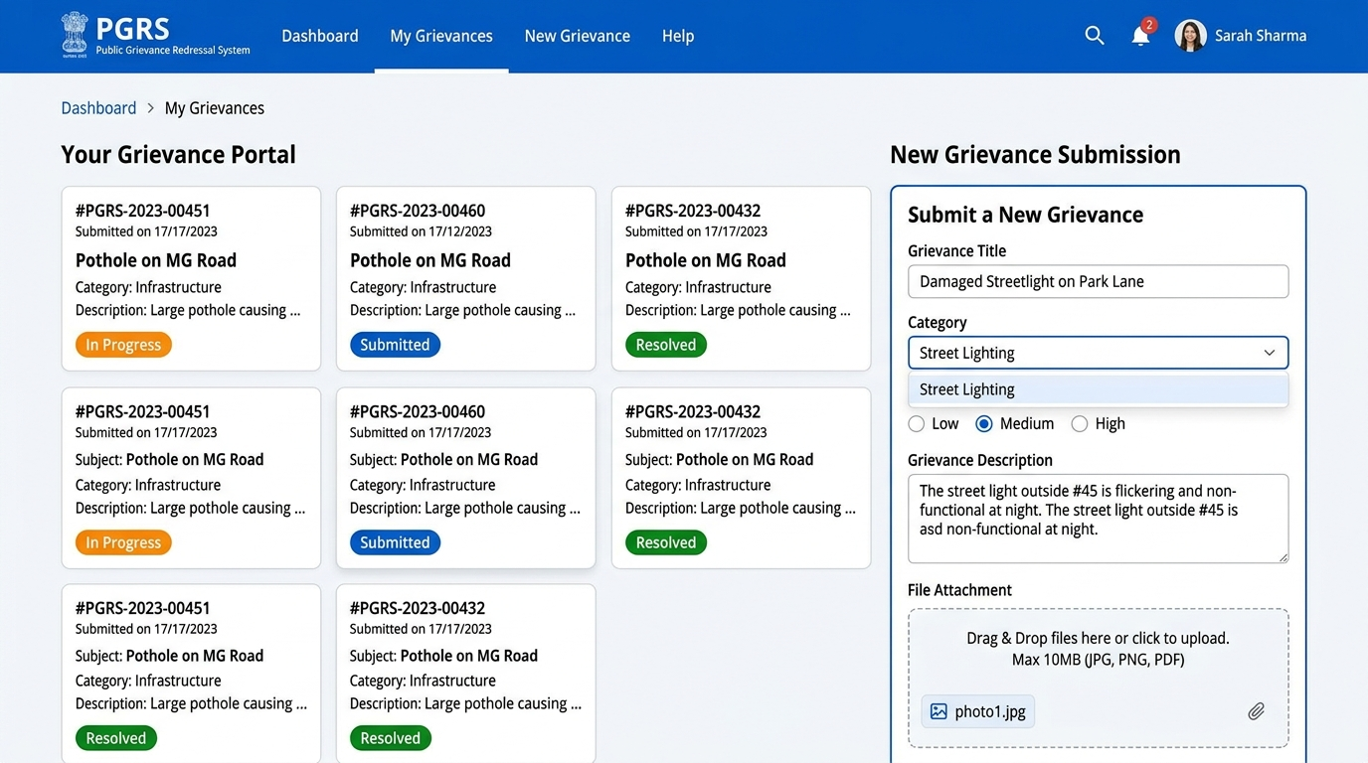
Figure B.9.1: Citizen Grievance Submission & Real-time Tracking Portal
Key Interface Capabilities:
• Multi-step grievance registration form with automated GRN generation.
• Real-time status tracking timeline showing current resolution stage.
• File attachment upload preview for evidence documents (JPG, PNG, PDF).
• Resolution verification and citizen feedback rating module.

8.2 Officer Grievance Resolution Workspace
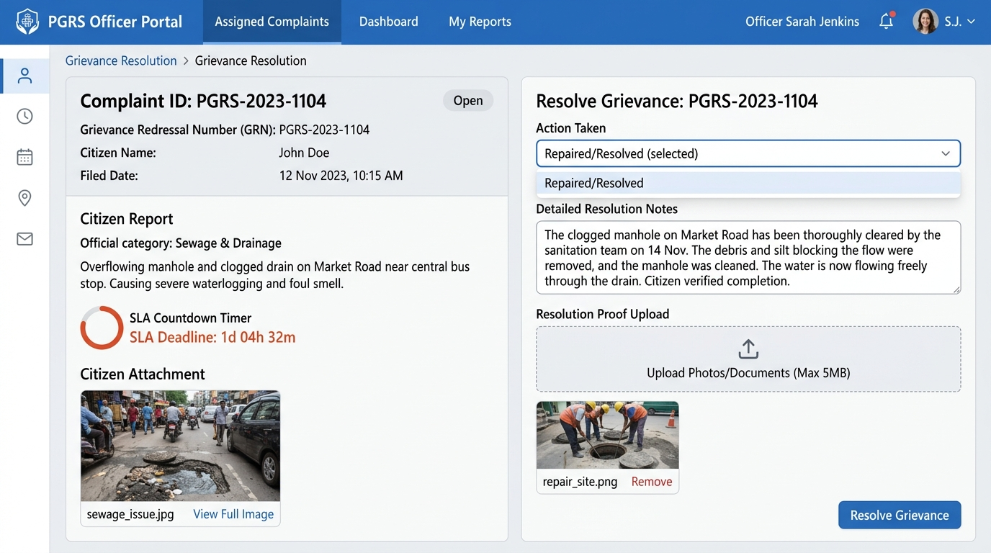
Figure B.9.2: Officer Grievance Management & Resolution Workspace
Key Interface Capabilities:
• Task-centric worklist displaying assigned grievances with priority indicators.
• Interactive status update controls (Under Investigation, Pending Info, Resolved).
• Multer-integrated resolution proof upload interface.
• SLA countdown timers and deadline warnings for active complaints.

8.3 Department Head Workflow & Escalation Interface
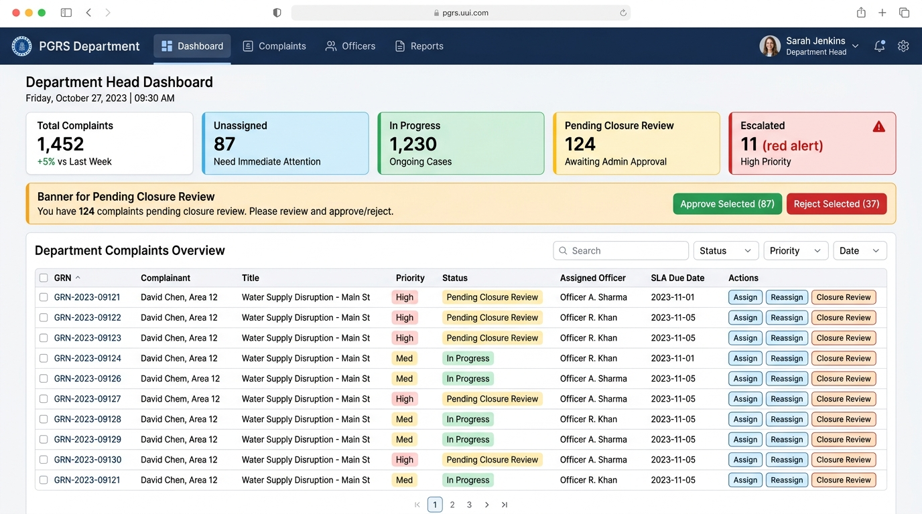
Figure B.9.3: Department Head Workflow Review & Closure Approval Workspace (UC-09 to UC-16)
Key Interface Capabilities:
• Complaint review and officer assignment / reassignment engine.
• SLA escalation monitoring panel highlighting delayed complaints.
• Resolution proof verification and closure approval/rejection modal (UC-15).
• Departmental performance analytics and custom report export.

8.4 Administrator Analytics & Governance Console
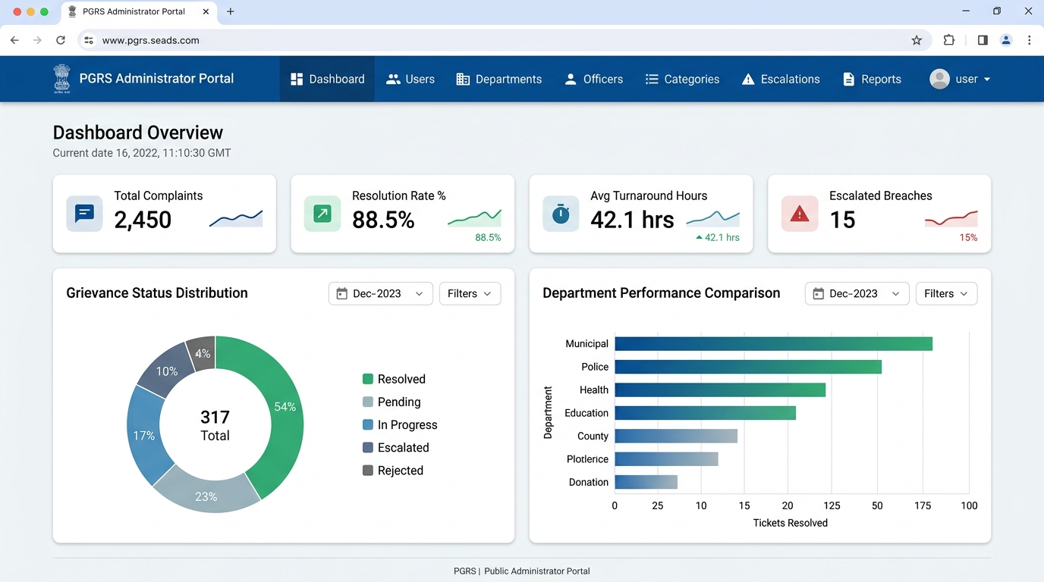
Figure B.9.4: Administrator Analytics & System Governance Console
Key Interface Capabilities:
• System-wide analytics dashboard showing total, resolved, pending, and escalated grievances.
• Role-Based Access Control (RBAC) user management and officer allocation.
• Department and category activation/deactivation controls.
• SLA escalation rule configuration and audit log inspector.

Appendix C: To Be Determined List
# | TBD Item | Responsible Party | Target Date
1 | Specific government data retention policy duration to confirm minimum record storage period. | Project Sponsor | TBD
2 | SMS gateway vendor selection (Twilio vs MSG91) and API integration specifications. | Technical Lead | TBD
3 | Exact SLA period (working days) for each grievance category to be defined by government stakeholders. | Government Stakeholder | TBD
4 | Confirmation of supported regional languages for future multilingual interface. | Project Manager | TBD
5 | Integration requirements with existing government portals (e.g., UID/Aadhaar verification). | Government IT Dept. | TBD
6 | Exact file format and layout specifications for report exports required by department heads. | Department Heads | TBD

